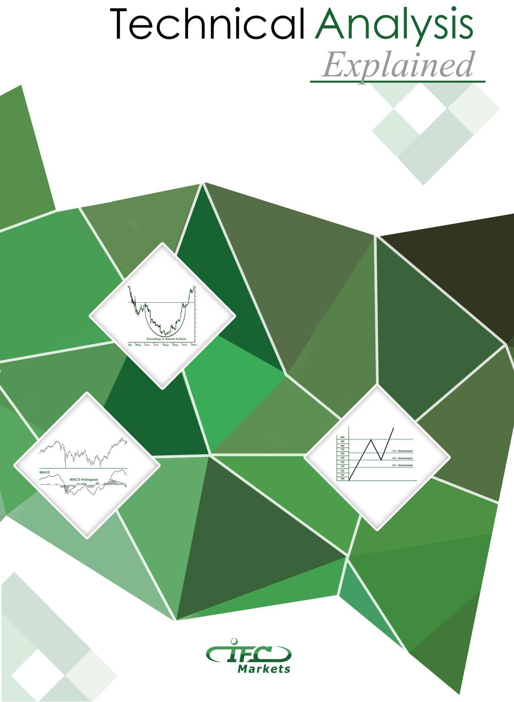


Contents
Contents 1
Introduction 3
Chapter I 4
What is Technical Analysis? 4
1.1 Definition of Technical Analysis 4
  - Philosophy of Technical Analysis 4
  - Technical Analysis vs. Fundamental Analysis 5
  - Technician or Chartist? Is There Any Difference? 6
  - Different Theories on Technical Analysis 6
Chapter II 8
Trend In Terms of Technical Analysis 8
  - Definition of Trend 8
  - Types of Trends 8
  - Support and Resistance Levels 10
  - Trend Reversal 12
  - Trendline 14
  - Channel Line 16
  - Percentage Retracements 18
  - Price Gaps 18
  - Trend Classification 19
Chapter III 22
Chart Construction 22
  - What is a Chart? 22
  - Types of Charts 24
  - Chart Patterns 28
3.2.1. Reversal Chart Patterns 29
3.3.2. Continuation Chart Patterns 32
  - The Importance of Volume 35
Chapter IV 37
Technical Indicators 37
  - What is a Technical Indicator? 37


1


  - Various Classifications of Technical Indicators 37
  - Major Technical Indicators 37
Conclusion 41
Bibliography 42

2

Introduction
The financial market is one of the most exciting and fast-paced markets in the world which day by day attracts new traders and investors. Though it provides plenty of opportunity for investors in order to be successful, each investor should understand the basics behind market movements and analyze securities.
The methods used for analyzing securities and making investment decisions fall into two categories: fundamental and technical analysis. Fundamental analysis considers macroeconomic factors to estimate the value of a security, while technical analysis is constrained only to the price movements in the market. Technical analysis attempts to understand the market psychology by studying the market itself. For this reason, some analysts offer that a better name for the use of such kind of market analysis might be risk/return analysis or market psychology.
At its core technical analysis is a method of determining if a security or the market is worth buying or selling. If one understands the essence, benefits and limitations of technical analysis, it can give him new skills to become a better trader. And as John Murphy, the father of inter-market technical analysis, states “Technical analysis is a skill that improves with experience and study. Always be a student and keep learning.”
In the first chapter of our book, we'll introduce you to the subject of technical analysis-what it is and why it is used. In the second chapter we are going to discuss the trend with all its peculiarities and key points. Chapter 3 and 4 are devoted to the illustration of technical charts and indicators, their major types and how they work to signal the right market direction. Thus, you will be introduced to the main tools and techniques used in technical analysis.

3

Chapter I

What is Technical Analysis?

1.1 Definition of Technical Analysis

Technical analysis is the study of market action primarily through the use of charts for the purpose of forecasting future price trends. By “market action” the following three main sources of information are implied: price, market volume, and open interest, the latter referring only to options and futures. The terms “price action” and “market action” are very often used interchangeably.
The history of technical analysis goes back to 1900s, and its roots can be found in the Dow Theory developed by Charles Dow. The principles that come from this theory are the price trending, convergence and divergence, as well as support and resistance levels.
Technical analysis is a crucial method of evaluating assets based on the analysis and statistics of past market action, such as past prices and past volume. The main goal of technical analysts is not the measuring of asset’s underlying value, they attempt to use charts or other technical analysis tools to determine patters that will help to forecast future market activity. Their firm belief is that the future performance of markets can be indicated by the historical performance.

Philosophy of Technical Analysis

Technical approach is based on the following three premises:
    - Market action discounts everything.
    - Price moves in trends.
    - History repeats itself.

Market action discounts everything
This premise is perhaps the most fundamental one, since nothing else coming forth from it can make sense, unless one has completely understood it. Technical analysts believe that each fundamental, political, economic and psychological factor that can possibly affect the price, is reflected in the price of the market. All that they claim is that price action should reflect changes in supply and demand. Together with the increase of demand the price will rise, and, conversely, if supply exceeds demand, prices will fall. This kind of action is at the base of fundamental forecasting; therefore, all technicians indirectly study fundamentals. The charts themselves do not cause markets to go up or down. These are the forces of supply and demand, the economic factors that lead to bullish and bearish markets.
Actually, chartists do not try to find out why the prices fall or rise. They can be aware of the trend the market is likely to go by simply studying price charts and technical indicators. They know that there surely exist reasons why markets move up or down and meanwhile believe that there is no necessity to reveal those reasons for making predictions.

4

Price Moves in Trends
There is a corollary to this assumption- a trend in motion is more likely to continue than to reverse. In technical approach once a trend has been established, the future price is accepted to be in the same direction rather than to be against it. The primary goal of charting the price action is to fix trends in early stages of development to later trade in the direction of those trends. So that the entire approach of this trend-following premise is based on the already existing trend, until signs of reversal are indicated.

History Repeats Itself
This premise brings forward the concept that the key to understanding the future is based on the study of the past. The circular nature of price movements is related to the human psychology, meaning that market participants tend to react similarly to identical market events. The analysts use certain chart patterns to analyze market movements. Most of those charts that were identified about a century ago, reflect certain pictures indicating the rising or falling psychology of the market.
Because of the simple reason that those patterns worked well in the past, they are strongly believed to be as much useful in the future. They are based on the study of human psychology which is stable and does not tend to change.

Technical Analysis vs. Fundamental Analysis

As it is well known, the two wide spread types of analysis methods to study price trend are technical analysis and fundamental analysis. Comparing technical and fundamental analyses to each other is one of the best ways to understand them.
While technical analysis is focused on the study and past performance of market action, fundamental analysis concentrates on the fundamental reasons that make an impact on the market direction.
The purpose of both of these methods is an attempt to forecast and determine the future price movements. The difference is based on how they achieve that objective. Fundamentalists study the cause of price movement, whereas the technicians study the result. As we mentioned above, technicians do not find it necessary to know the reasons of market changes, but fundamentalists try to discover “why”. Therefore, technicians, who are also called chartists are interested in the price movement, they try to understand and study the emotion in the market.
The second distinctive factor for these two types of analyses is the time horizon. Actually technical analysis takes considerably short time to analyze the market, as compared to fundamental analysis. Technical analysts can do their research based on daily, weekly or monthly data. But conversely, fundamentalists may look at data over years. Since each of those approaches takes different time frames, they are applied for reaching different trading or investment goals.
Generally technical analysis is used for a trade, while fundamental analysis is more appropriate for investment purposes. Traders buy an asset in the hope that the latter will rise in value and they will be able to sell it at a higher price. The reason why fundamental analysts use so long timeframe is the following: the data they study are generated much more slowly than the price and volume data used by technical analysts.
Though these two types of analyses are viewed as polar, many traders and investors, who have active participation in the market use both. For example, a technician may refer to fundamental analysis to add
5

strength and reliability to technical signals, to reaffirm his decision while buying or selling an asset. And, alternatively, fundamental analysts may use technical analysis tools to identify the best time to enter into a security.
The problem is that charts and fundamentals are often in competence. Technical analysts believe that their approach dominates fundamentalists. If a trader or an investor had to make a choice between these two theories, he would give preference to technical analysis. This is because technical approach includes the fundamental. If the fundamentals are reflected in the market price, their study already becomes unnecessary. Herein, chart reading serves as a shortcut of fundamental analysis. The opposite, however is not possible. Fundamental analysis does not cover the study of price action and it’s quite possible to trade using only the technical approach. To trade on financial markets one cannot do but take into consideration the markets’ technical side.

Technician or Chartist? Is There Any Difference?

Among various titles given to the practitioners of technical analysis are: chartist, visual analyst, market analyst and technical analyst. If once all they meant the same thing, together with the increasing specialization in this field there have been made some distinctions in terms. Since till the last decade technical analysis was based on mainly the use of charts, the terms “chartist” and “technician” stood for the same concept. But this does not hold true any longer.
Now in the broad field of technical analysis two types of practitioners are distinguished: chartists and statistical technicians. Charts are the primary working tools in technical analysis and the term “art charting” has been given to this approach, since chart reading is really an art. This is largely because the success of the approach greatly depends on the skills and experience of a chartist.
Statistical technician considers primary principles, tests and quantifies to develop mechanical trading systems. These systems are programmed into a computer and generate mechanical “buy” and “sell” signals. That’s main purpose is to eliminate human emotional factor in trading. The statisticians may not use charts in their work, and their work can be constrained to the study of market action. From this it follows that all chartists are also technicians, however not all technicians are chartists.

Different Theories on Technical Analysis

The Dow Theory, named after its creator Charles Dow, is the grandfather of technical analysis. While most technicians view the theory as somewhat dated, the approach of many more statistically sophisticated methods are the variants of Dow’s approach. The main objective of Dow Theory is to identify long-term trends in stock market prices. The two indicators used are the DJTA (Dow Jones Transportation Average) and DJIA (Dow Jones industrial Average). The DJIA is an important indicator of underlying trends, while the DJTA serves to confirm or reject the signal.
The Dow Theory posits three forces simultaneously affecting stock prices:
- The primary trend, which indicates long-term movement of prices and lasts from several years to several months.
- Secondary (intermediate) trend, which is caused by short-term deviations of prices.
- Tertiary (Minor) trend which indicates daily fluctuations.

6

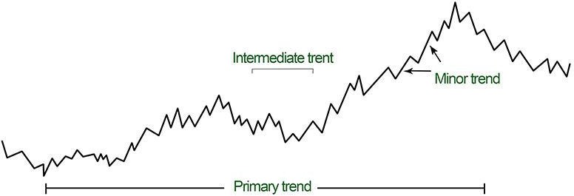

Figure 1.1 Three types of trends according to Dow Theory
Recent variations of Dow Theory are the Elliot Wave theory and the Kondratieff Wave theory. The idea of Elliot Wave theory is that security prices can be described by a set of wave patterns. Long-term and short-term wave cycles are superimposed and result in a complicated pattern of price movements, but by interpreting the cycles one can predict broad movements. Similarly, Kondratieff Wave theory, named after a Russian economist, asserts that stock market moves in broad waves lasting between 48 and 60 years.
The Kondratieff waves are, thus, analogous to Dow’s primary trend. Kondratieff’s assertion is hard to evaluate empirically, because cycles that last about 50 years provide only two full data points per century, which are hardly enough data to test the predictive power of the theory.

Conclusion
The principles of technical analysis presented in this chapter are widely applied in all markets. How analysts perform all the operations and get the full picture of market action we’ll discover in following chapters.

7

Chapter II

Trend In Terms of Technical Analysis
Trend represents one of the most essential concepts in technical analysis. All the tools that an analyst uses have a single purpose: help to identify the market trend. The expressions like “trend is your friend” or “Never buck the trend” are not used accidentally. The meaning they contain is more than deeper. So, it is worth properly understanding what the trend is and what type of trend is possible to differentiate.

Definition of Trend

The meaning of trend is not so much different from its general meaning- it is nothing more than the direction in which a market moves. But more precisely, market does not move in a straight line, its moves are characterized by a series of zigzags which resemble successive waves with clear peaks and troughs or highs and lows, as they are often called. Thus, in technical analysis it is the movement of those highs and lows that form a trend.
Thus, trend is the direction of market indicated by successive peaks and troughs.

Types of Trends

As we mentioned above trend is comprised of a series of highs and lows, and depending on the movement of those peaks and troughs one can understand the trend’s type in market.
Though most people think that market can be either upward or downward, actually there exist not two but three types of trends:
    - Uptrend
    - Downtrend
    - Sideways
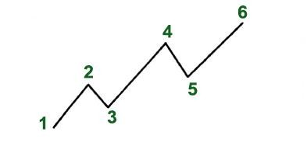
An uptrend is defined as a series of higher peaks and higher troughs
Figure 2.1 An example of an uptrend with ascending highs and lows

8

As it is clearly mentioned on the chart, the points stand for identifying highs and lows. The first peak represents the point 2 which is determined after the price falls from that point. Herein, point 3 is the trough which is determined after the price falls from the peak. And this should be continuous so that each successive trough must not fall below the previous lowest point. Only in that case the trend can be accepted as an uptrend, otherwise the trend is considered reversal.
A downtrend is right the opposite; it is formed of lower peaks and lower troughs

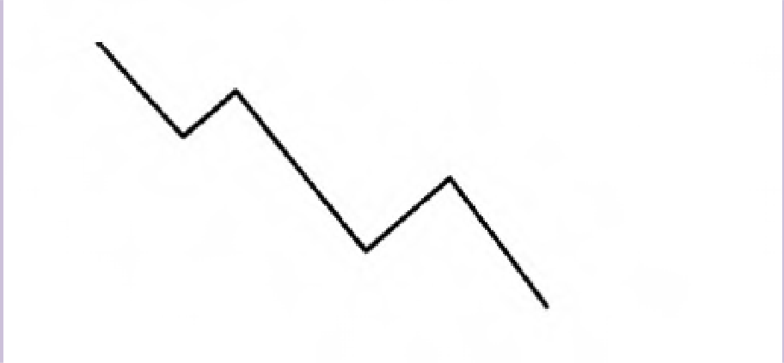
Figure 2.2 An example of a downtrend with descending peaks and lows

A sideways trend is constituted of many horizontal peaks and troughs, and there is no obvious indication of trend. The direction in which the security price moves is absolutely opaque.

This type of market direction is sometimes referred as “trendless”. This kind of action reflects the period when the forces of supply and demand are in a relative balance. The wide variety of technical analysis tools which are primarily designed to follow the trend become powerless when market enters this “trendless” phase. It is during these periods that traders fail and experience great losses. The failure does not depend on the trend-following system; the system needs a trend to do its work. The reason is hidden in the trader who strives to apply the trend-following system in a non-trending market.

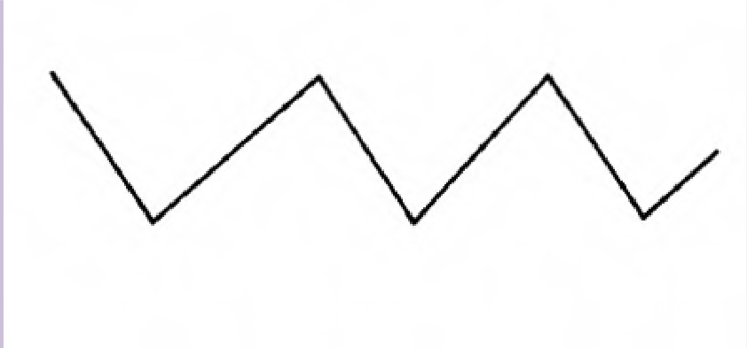
Figure 2.3 An example of a sidewise trend with horizontal peaks and troughs

9

Traders and investors confront three types of decisions: go long, i.e. to buy, go short, i.e. to sell, or stay aside, i.e. to do nothing. During any type of trend they should develop a specific strategy. The buying strategy is preferable when the market goes up and conversely the selling strategy would be right when the market goes down. But when the market moves sideways the third option – to stay aside- will be the wisest decision.

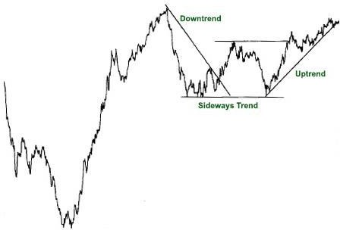

Figure 2.4. An example of a downtrend which gradually turns into an uptrend. The first part shows a downtrend, then the market moves sideways and starts to go up.

Support and Resistance Levels

Troughs and peaks in technical analysis are usually mentioned by their appropriate names which are support and resistance respectively.
The term support indicates the area on the chart where the buying interest is significantly strong and surpasses the selling pressure. It is usually marked by previous troughs. In an uptrend of the figure 2.5 the points 2 and 4 are considered support levels.
Resistance level, contrary to the support level, represents an area on the chart where selling interest overcomes buying pressure. It is usually marked by previous peaks. The points 1 and 3 in the figure identify resistance levels.

10

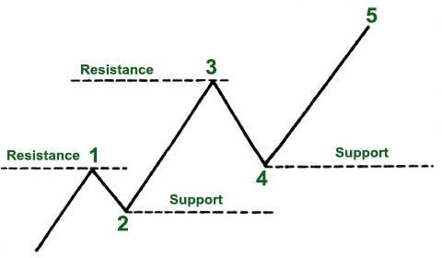

Figure 2.5 Rising support and resistance levels in an uptrend
The image is different with a downtrend (see Figure 2.6) which is composed of descending peaks and troughs. In a downtrend the points 1 and 3 indicate support levels and, consequently, the points 2 and 4 show resistance levels.

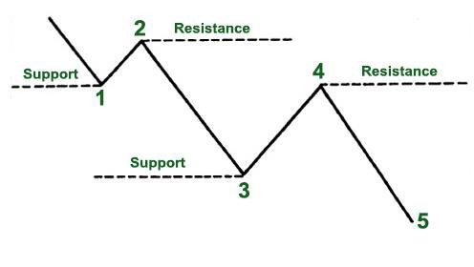
Figure 2.6 Falling support and resistance levels in a downtrend
For an uptrend to go on each successive support level should be higher than the preceding one, and each successive resistance level should be higher than the one preceding it. In case this is not so, for
11

instance, if the support level comes down to the previous trough, it may signify that the uptrend is coming to the end or at least it is turning into a sideways trend. It is likely that trend reversal from up to down will occur.
The opposite situation takes place in a downtrend; the failure of each support level to move lower than the previous trough may again signal changes in the existing trend.

Trend Reversal

Another interesting aspect of trend is the reversal of support and resistance levels, which is known as "trend reversal", "rally" or "correction".
An uptrend which is defined by successive higher highs and higher lows can reverse into a downtrend by changing to successive lower highs and lower lows.

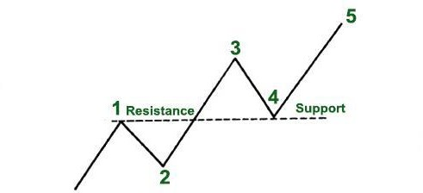

Figure 2.7 Trend reversal in an uptrend
A downtrend, which is defined by lower highs and lower lows, can reverse into an uptrend by changing into successive higher highs and higher lows. To put it more bluntly, a resistance level becomes a support level, and a support level becomes a resistance level.

12

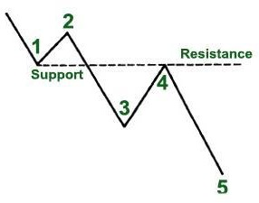

Figure 2.8 Trend reversal in a downtrend
A reversal can be either a positive or a negative change against the prevailing trend. This is of high significance for market participants and analysts, since those patterns indicate the necessity of taking another trading strategy on the same security.

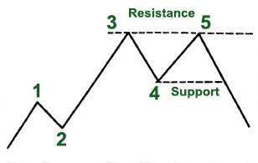
Figure 2.9 Downside trend reversal
As it is clearly shown in the picture, point 5 fails to exceed the previous peak (point 3) and is followed by a trough which violates the previous low (point 4). This type of pattern is called a double top which we will discuss in chapter 3.
To understand this properly, let’s group traders and other market participants into three categories:
the longs, the shorts and the uncommitted.
The longs are the ones who have already bought a security, the shorts are those who have already sold it and the uncommitted form the group of participants who either remain undecided or have exited the market. Once the market starts moving higher from the support level the longs will be delighted only
13

regretting for not having bought more. But this will create a negative situation for the shorts, who will appear on the wrong side of the market and only hope for a dip back to the area where they went short, so that they can get out of the market they got in.
The group of undecided realizing that prices are increasing will decide to enter the market on the long side.
All the mentioned members have a great interest in that support area. The importance of the support and resistance areas is strengthened based on the volume, time spent there and how recently the trade has taken place.

Trendline

Another technical tool applied by a chartist is the trendline. Drawing a trendline does not cause any difficulty, it is as simple as drawing a straight line which follows the trend. The line is used for indicating the trend and also identifying trend reversals.
There can be distinguished two types of trendlines: up trendline and down trendline. An up trendline is a straight line drawn upward to the right along successive lows. A down trendline is drawn downward to the right along successive highs.
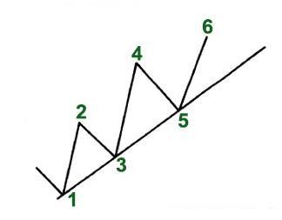

Figure 2.10 An up trendline which is drawn under the rising reaction lows

14

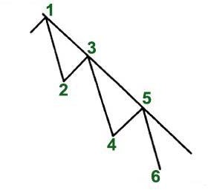

Figure 2.11 A down trendline which is drawn over successively falling highs
Drawing a correct trendline, like any other aspect of technical analysis, requires practice and experiment with different lines before finding the correct one. There are certain factors that are very useful in this respect.
Firstly, the trend should be clear and evident. So, for drawing an up trendline there must be at least two reaction lows where the second low is higher than the first. Thus, at least two exact points are necessary to draw any straight line. This refers to a tentative trendline. In order to confirm the validity of the trendline, third point becomes necessary. This kind of trendline is referred to as a valid trendline.
As long as the trendline is stable, it can be used as a determinant of buying and selling areas. But once it is violated, it is one of the best warnings of a change in trend.
The significance of a trendline is determined by the duration it has been intact and by the number of times it has been tested. A trendline which has been touched for 10 times is more significant than the one which has been tested for only three times. Similarly, a trendline would be of more importance if being in effect for 7 months rather than for 7days.
More significance of a trendline indicates more confidence and more important penetration.

Fan Principle
There are situations when prices rally back on the level of trendline. In such cases, after the break, a new trendline is drawn and the previous one becomes a resistance line. Similarly, if the first trendline is violated, the third one is drawn. And if the price breaks the third line, it is most likely that trend reversal will take place.
In figure 2.12 it is shown how prices rallied to but failed to penetrate line 1. Line 2, second trendline, is also broken. After another rally fails, a third line is drawn. The break of that third trendline usually indicates that prices are moving lower.

15

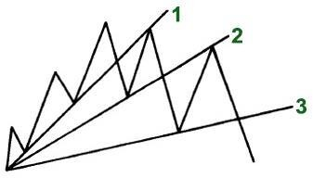

Figure 2.12
This kind of situation is referred as “Fan principle” whose name derives from the appearance of the lines that resemble a fan. Here it is important to note that the breaking of the third line is a signal of valid trend reversal.

Channel Line

Channel lines, or as they are sometimes called return lines, are additions of two parallel trendlines which act as support and resistance levels. As we have already covered, an up trendline connects a series of peaks, while a down trendline connects a series of troughs.
Drawing a channel line is quite simple. If we want to draw it in an uptrend, firstly it is important to draw the basic up trendline along the lows as shown in the figure 2.13 (points 1, 3, 5). Then it follows to draw a dotted line parallel to the basic trendline (starting from the first peak, point 2). Both the dotted and basic lines move in the right direction forming a channel. If the price increases and the next rally reaches and backs off from the channel line (mentioned by point 4), then a channel may exist. And if the price declines and falls back to the trendline, (shown by point 5), then we can say that a channel exists.

16

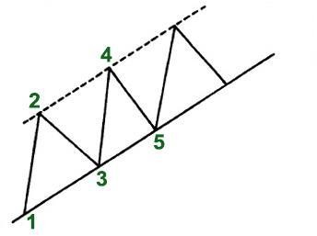

Figure 2.13

The same can be said for a downtrend, however in the opposite direction.
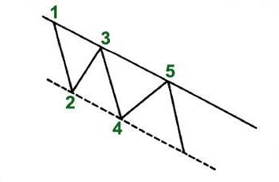

Figure 2.14
Whether a channel is upward or downward, its interpretation is the same. Traders and investors expect a particular security to trade between support and resistance levels, until it breaks beyond one of these levels. Aside from clearly indicating the trend, channels are mainly used to illustrate the important areas of support and resistance. They can be used for short term profit taking. Like a trendline, the longer the channel remains intact and the more often it is successfully tested, the more reliable it becomes. While the breaking of the basic trendline indicates an important change in trend, the breaking of a rising channel line indicates an acceleration of the existing trend.
It should be noted that the basic trendline is much more reliable. The channel which is often included in the toolkit of a chartist, is considered a secondary use of trendline technique.

17

Percentage Retracements

While following the market movements one can easily notice that after a particular move, prices retrace the previous trend by some percent before continuing in the original direction. The amount that prices retreat from the high to the low can be measured using the technique “percentage retracement”.
Let’s bring an example. If a market trends high reaching from 100 level to 200, in most cases the price retraces nearly half of the move (at about 150 level). This kind of phenomenon is known as 50% retracement and happens quite often.
Besides 50% retracement, there exist the one-third and the two-thirds retracements. Different approaches offer different amounts of minimum and maximum retracements. Thus, according to Dow Theory, there are 3 percentage retracements- 33%, 50% and 66%. But as for Elliot Wave Theory and Fibonacci ratios, the minimum and maximum retracements are 38% and 62%.

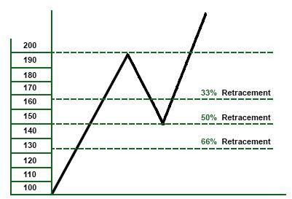
Figure 2.15
This means that usually during a trend correction the market retraces at least one-third of the previous move. It is very important for traders to be aware of such information and use the buying and selling opportunities correctly. If the trader wants to find a beneficial buying area he can compute a 33- 50% area on the chart and use that zone for buying decisions. If the trader wants to find a beneficial selling area he can compute a 62-66% area on the chart and use that zone for selling decisions.
The maximum retracement usually creates a critical area. If the correction stops at the two-thirds point it becomes a less risky area in an uptrend for buying and in a downtrend for selling. In case prices surpass the maximum point, the condition from retracement turns into trend reversal.

Price Gaps

Price gaps represent such areas on a chart where no kind of trade has been executed. They are open spaces on a chart which mostly appear on daily bar charts but can be seen on weekly and monthly charts as well.
Gaps can be of three types: breakaway, runaway/measuring and exhaustion.

18

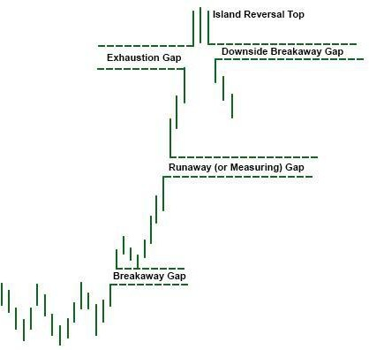

Figure 2.16
The breakaway gap appears when an important price pattern is completed and usually indicates the beginning of an essential market move. It can also be seen when a major trendline breaks and signals a reversal pattern. Breakaway gap usually is not filled.
The runaway or measuring gap appears somewhere in the middle of the move when prices form a second type of gap. In an uptrend this kind of gap indicates a market strength, while in a downtrend it’s a sign of market weakness.
The exhaustion gap appears near the end of the market move when the breakaway and runaway gaps have already been identified. Sometimes after the formation of exhaustion gap prices trade in a narrow range for a few days and only then gap to the downside. The exhaustion gap to the upside which is followed by a breakaway gap to the downside completes the island reversal pattern and usually looks like an “island surrounded by water or space''.

Trend Classification

Actually, trends can be of different lengths ranging from very short term trends that cover minutes and hours to very long term trends which can last a decade. However, technicians classify trends into three main groups: long-term, intermediate and short-term trends.
Long–term trend, which is also known as major trend, is considered the trend which lasts longer than a year.
An intermediate trend is defined as a one-to-three-month trend and a short-term, or so called near- term trend, is expected to last less than a month.

19

Each trend can become a portion of the next larger trend. For example, a long term trend consists of several intermediate trends which usually move against the long-term trend and are referred as corrections. If a long-term trend is upward and the market pauses to correct itself for some period to resume its upward path, the correction is considered to be an intermediate trend.
Short–term trends in their turn are components of intermediate and long-term trends. This procedure that each trend is a part of the next larger trend and consists of smaller trends takes place many times (see figure 2.17).
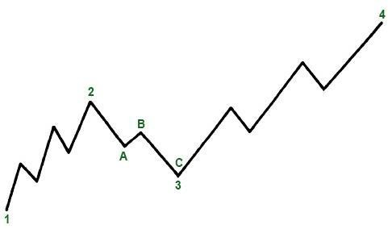

Figure 2.17
In the displayed figure the long term upward trend is shown by peaks and troughs mentioned by the points 1, 2, 3, 4. The points 2 and 3 represent intermediate trend and show the corrective phase within the major trend. Moreover, this intermediate trend consists of three smaller trends, near trends (points A, B, C). At point C the major trend seems to be still up, whereas the intermediate and near term trends are down. At point 4 all the trends are up. Therefore, it becomes very difficult to tell the exact trend in a given market, and analysts usually define it by different trend classifications, discussed in our example.
How traders perceive a trend may cause a bit of misunderstanding while defining a trend. For a trader of a long-term position a few days' price action may be unimportant, while for a day trader the same time frame may be accepted as a major trend. Thus, it is also important to understand and take into account different degrees of trend.
Another important factor in trend analysis is the usage of a right chart which is constructed to best reflect the type of trend. So, daily charts are mainly used to analyze intermediate and short-term trends. The longer the trend, the more significant it is, e.g. a one-month trend is not considered as much important as a two-year trend.

20

Conclusion
In this chapter we presented the core features of chart analysis, including channels and trendlines, support and resistance levels, gaps and percentage retracements. We also covered the main classes of trends whose identification helps to trade with and not against the market.

21

Chapter III

Chart Construction

3.1. What is a Chart?

In technical analysis a chart is a graphical representation of price movements over a certain time
frame. It can show security’s price movement over a month or a year period.
The chart below will help to understand how charts reflect price changes and how to read them.
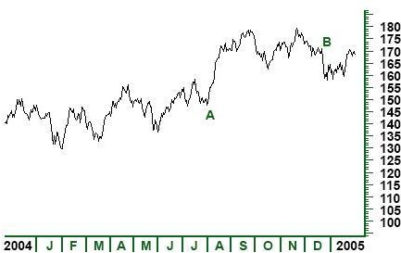

Figure 3.1
Figure 3.1 represents price movements of a security over a year period. The horizontal x- axis at the bottom of the chart shows the date or time scale. The vertical y-axis shows the price scale. Thus, in the given example it is shown that in July 2004 (A) the price of security was around $150, but in December 2004 (B) its price reached around $170. This data tells us that the price of the security has risen between July 2004 and December 2004.
- The Time Scale
The time scale shows the range of dates which can vary from seconds to decades. Most widely used time scales are intraday, daily, weekly, monthly, quarterly and annually. Intraday charts, as the name implies, plot price movement within a particular day ranging from several minutes to the whole trading day. In the same way, weekly, monthly or yearly time scales cover both intermediate and short–term trends in price movement and are mainly used to analyze longer term trends.

22

- The Price Scale (Arithmetic and Logarithmic scales)
The price scale on the right side of the chart shows security’s current price and compares it to past
data. The structure of the scale can be either arithmetic (linear) or logarithmic.
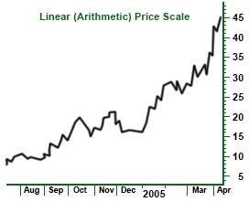
Linear scale means that the space between each price point is separated by an equal amount (see figure 3.2).
Figure 3.2
In this figure it is shown that each point on the linear scale is equidistant; each price point increases by $5. In this case the price scale does not show the effects of percent change and measures movements in absolute terms.
Logarithmic price scale shows that the distance between points will be equal in terms of percent change (see figure 3.3). Though price changes from 10 to 20 and from 40 to 50 are shown by the same distance on a linear scale, the percent change is different; a price change from 10 to 20 is a 100% change, while a price change from 40 to 50 is only a 25% increase. Thus, the 100% increase is represented by a larger space on the chart, while the 25% increase is shown by a smaller space.

23

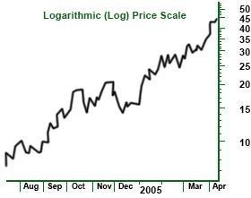
Figure
3.3
Usually stock market chart analysts use log charts, whereas futures chart analysts give preference to
arithmetic charts. The opportunity of using each of them is great since charting software packages allow both types of scaling.

Types of Charts

Depending on what information traders search for and what skills they master, they can use certain types of charts. The main types of charts are: the bar chart, the line chart, the candlestick chart and the point and figure chart.

Line charts
The line chart is considered the most basic chart, since it plots only the closing price over a set period of time. It does not provide such information like high, low and opening prices and is formed by connecting closing prices (see figure 3.4). Most chartists consider the line chart a valid measure of price activity because they believe that closing is the most essential price in trading data.
In the following example and in other examples as well (figures 3.4, 3.5, 3.6) the price data of S&P 500 Index between January 2006 and May 2006 are presented. What is important here to notice is that the data are identical on all charts but the way they are plotted and represented is quite different.

24

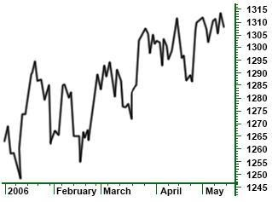

Figure 3.4 A line chart: This type of chart creates a solid line connecting the successive closing prices.

Bar Charts
The bar chart is a more expanded version of the line chart with additional information. It is called bar chart because it consists of a series of vertical bars that show each datum. The bar chart aside from closing prices also plots the open, high and low prices.
The closing and opening prices are shown on the bar by a horizontal dash either on its left or right sides. The opening price is represented by the dash on the left of the bar. The closing price, herein, is shown by the dash on the right of the vertical bar. Usually, if the left dash is lower than the right dash this means that the security has gained value. If the right dash is lower than the left dash, it means that the security has decreased in value. In such cases bars are colored red once more showing the low value of security over that set time (see figure 3.5).

25

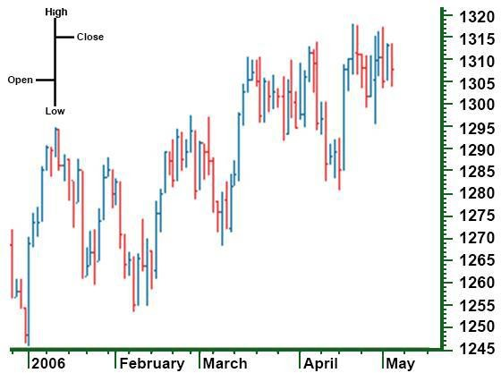

Figure 3.5 A bar chart: each vertical bar represents one action

Candlestick Charts
The candlestick chart is the Japanese version of the bar chart and plots the same four prices as the bar chart (high, low, opening and closing prices), however the visual presentation differs. The difference mainly lies in the formation of a wide bar on the vertical line which shows the difference between the opening and closing prices.
On the candlestick chart the thin line, also called shadow, shows the price change from the high to the low. A wider portion of the bar, also called real body, shows the distance between the opening and closing prices.
The colors as in the bar charts, here also are used to explain the price performance over the trading period. Though different sites use different standards for candlestick color configuration, there are two color constructs for showing days when price goes up and one for days when the price goes down (see figure 3.6). The candlestick will be white or clear if the security price is up and closes above the opening trade. But if the price is low, the candlestick will usually be red. In other words, if the closing price is higher than the opening price, the real body will be white (positive), and if the closing price is lower than the opening price, the real body will be red (negative).

26

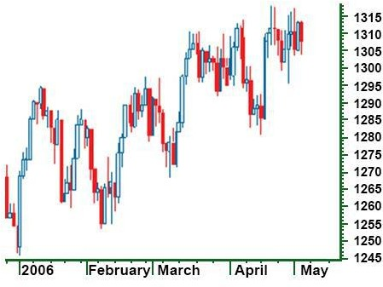

Figure 3.6 A Candlestick chart

Point and Figure Charts
The point and figure chart though not so well known and widely used by an average investor, has a long history and goes back to the first technical traders. This type of chart shows the same price action in a quite compressed format; it simply reflects price movements and is not concerned about time and volume and insignificant price movements. Besides this, on the point and figure chart it is much easier to spot the buy and sell signals than on the bar chart.
The numbers and letters on the chart represent months through which traders can make an idea of the date (see fig. 3.7).

27

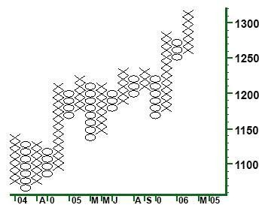

Figure 3.7 The point and figure chart: The X column shows rising prices and the O column shows falling prices.
The boxes on the chart represent the price scale based on the price of the security. This means that the higher the security price, the more each box represents.
Another important aspect on this chart is its reversal criterion. This indicates how much the price is to move away from the low to the high to create a new trend. In other words, it shows how much the price has to move for an X column to become an O column and vice versa.

Chart Patterns

Price patterns are certain formations that appear on charts creating a sign of future price movements. They have predictive value and are used by chartists to identify current trends and trigger buy and sell signals.
The theory of chart patterns is based on the basic assumption of technical analysis that history repeats itself. The main premise is that certain patterns appear many times on the chart and signal movements in a security based on the historical trend of a chart pattern.
Though each chart pattern has its own components and shows a certain movement, there is no chart that will tell for 100% how the security is about to move. This always arouses debates as what patterns are good and reliable, and this is why charting in most cases is referred to as rather an art than a science.
There are two major categories of price chart patterns: reversal and continuation. Reversal patterns indicate that an important reversal in trend will take place upon completion of the pattern. The continuation pattern, conversely, indicates a temporary pause in a market after which the existing trend will continue.

28

3.2.1. Reversal Chart Patterns

Reversal chart patterns are formed after the price level has reached the maximum value in the current trend. They signal the end of the current trend and the start of a new one.
A pattern which is formed during an uptrend signals that the price will soon decline. Conversely, the pattern formed during a downtrend, signals that the price is about to go up.
It is important to know where in the primary trend the pattern is most likely to appear. Patterns that appear at the market top are called distribution patterns, where traders can sell the instrument. On the other hand, patterns that appear at the market bottom, known as accumulation patterns, indicate the most efficient period of buying an instrument.
While discussing reversal chart patterns it is important to consider some common and essential points that form their basis.
- Existence of a prior trend
There must be a prior trend for the formation of a reversal pattern; if it is not preceded by a trend, there can be nothing to reverse.
- Breaking of important trendlines
Though the violation of a major trendline does not always indicate a trend reversal, it often signals the beginning of a sideways price pattern, which then can be identified as a reversal or a continuation type.
- Greater potential with larger pattern
Patterns with greater sizes, that is, with high volatility and long duration of building, are more important and the potential for ensuring price move becomes greater.
- Difference between top and bottom patterns
Top patterns usually take less time to build, they are shorter in duration and are more volatile. The volatility within bottom patterns is lower and it takes longer time to build a bottom pattern. In top patterns the prices tend to decline faster than they go up, herein, traders can more quickly make money by trading the short side of bear market, than by trading the long side of a bull market.
- Volume is more significant on the upside
Being a confirming factor in the completion of all price patterns, volume usually increases in the direction of trend. The completion of each pattern should be accompanied by certain increase in volume. At market tops in the early stages of trend reversal volume is not so important. On the other hand, at bottoms the volume increase is quite essential.

Major Reversal Patterns
The Head and Shoulders Pattern: This pattern, also known as head and shoulders top, is considered the most reliable of all other reversal patterns. Being formed in an uptrend head and shoulders pattern signals that the price is going to move in a downward direction.

It is a chart formation where price moves in the following way:

- Rises to a peak and declines
- Rises again, this time higher than the first peak, and declines

29

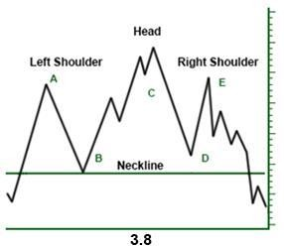
- Rises but not so high as the second peak, and declines.
The highest peak is called head and the left and right peaks which are at about the same height are called shoulders. A flatter trendline can be drawn under reaction lows (B and D), called neckline. If the price falls below the neckline a sell signal arises. The pattern is complete if the neckline is broken; only in that case the trend is considered reversed, and the asset can head a new direction.
The Inverse Head and Shoulders: This type of pattern is also called head and shoulders bottom and is exactly the opposite of head and shoulders top, discussed above. It signals that the security is going to make an upward move. Here again there are four steps to form the pattern starting from the left shoulder which is formed when the price declines
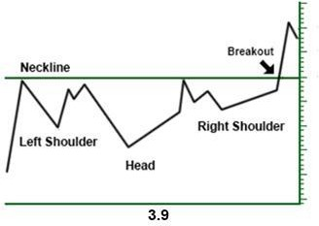
and rises. Then follows the formation of head, when the price declines lower than the previous low accompanied by a return to the previous high. The third step is the formation of the right shoulder which is higher than the previous low and is followed by a return to the neckline. This pattern is considered complete when the price breaks above the neckline.
Triple Tops and Bottoms: The triple top and bottom patterns are just slight variations of head and shoulders patterns.
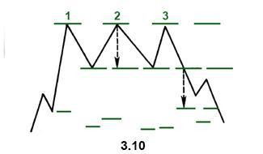
The main difference is that three highs or lows in triple tops and bottoms respectively are at the same level.
Triple tops are bearish reversal patterns formed when the security which is trending upward tests the same resistance level without breaking it through and each time falls to a similar support area. The pattern is considered complete when after the third decline the security falls through the support level. Thus, the price is expected to move in a downward direction indicating a sell signal.
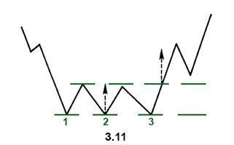
Triple bottoms are bullish reversal patterns that share all the features of the triple top, but they only signal a reversal of downward trend. They indicate that a security that is trading in a downtrend and tries to fall through the support level for three times, each time moves back to the resistance level.

30

The pattern is complete when the price moves above the resistance level and begins trading in an upward trend.
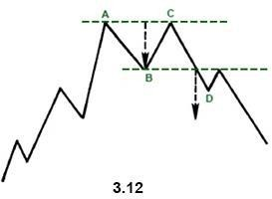
Double Tops and Bottoms: The double tops and double bottoms are again well known chart patterns which show a security’s attempt to continue an existing trend. After a few attempts to continue the direction, trend is reversed. By their formation
these patterns often resemble the letter W (in case of double bottom) or the letter M (in case of double top).
The double-top pattern signals the weakening of the preceding upward trend. It has two peaks at about the same level (points A and C). The market sets a new high on increased volume (A), then declines (B) on declining volume. The next high (C) is formed and again begins to fall back. The double
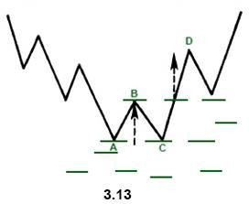
– top pattern is formed but it is not complete unless the security breaks down the support level (D) signaling the beginning of a downward trend.
The double bottom is the opposite pattern of the double top and signals a reversal of the downtrend. It is formed by setting a new low in the price movement (point A). After finding support the price rises to the resistance level (B) and then declines down to the previous low (C). These two lows (A and C) form the two bottoms on the pattern. But after forming the bottoms the price goes up. It is important to note that the security should break through the support level for trend reversal to take place (here changing from a downtrend into an uptrend).
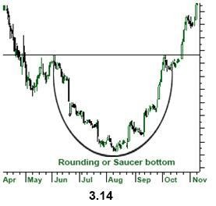
Saucer Bottom: Saucer bottom, also called a rounding bottom, is a long term pattern which signals a gradual and very slow shift from a downtrend to an
uptrend. It is referred to as a long term pattern, since it can last from several months to several years. It is rather difficult to tell when the pattern has been completed and calculate how prices will move in the opposite direction. The formation of a saucer bottom starts form a downward movement which gradually becomes lower and then is followed by a rise to the initial level of the downward movement creating a pattern which looks like a rounding bottom.
It is not necessary for the pattern to be followed only by a downtrend; it may also proceeded by a sideways movement formed after a downtrend.

31

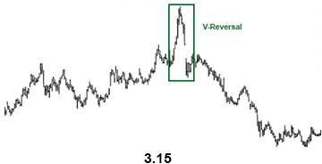
The distance from the initial high to the lowest level is considered the half of the distance of the saucer bottom. This helps chartists make an
idea when the pattern will be complete; if the first half of the pattern lasts a year, the signal is not expected to be formed until a year.
V-patterns or Spikes: Spikes are the most difficult patterns to deal with, since they happen very quickly with little or no transition period. They appear when the market has become so
overextended in one direction that a sudden event can cause the market change its direction very abruptly. Unfortunately, these sudden turns are difficult to spot in advance. The only way to know what to expect is to use certain technical indicators that help to determine when market have gotten over- extended.

3.3.2. Continuation Chart Patterns

Continuation patterns indicate that the sideways price movement on the chart is just a pause in the prior trend and that the next movement will be the continuation of the direction preceding the formation. When these patterns appear on the chart they indicate that the trend is likely to resume after the completion of the pattern. And the pattern is considered complete when after its formation the trend ''breaks out'' of the pattern and continues with the former trend. This is the main feature that distinguishes continuation patterns form reversal patterns.
Another factor that differs between these two types of patterns is the time duration. Reversal patterns take longer times to be formed and represent major trend changes. On the other hand, continuation patterns are classified as intermediate patterns and usually take shorter time to build. They can appear on all time frames, from a tick chart to a weekly chart.

Major Continuation Patterns
Triangles: Triangle patterns can be defined as a converging of the price range, with lower highs and higher lows. The converging price action creates a triangle formation. If the price goes on to converge, it will reach the apex of the triangle and the closer the price gets to the apex, the tighter the price action becomes.
There are three types of triangles: ascending, descending and symmetrical. Both ascending and descending triangles are variations of symmetrical triangle and differ from it in a very important sense. The ascending triangle is bullish and the descending triangle is bearish, while the symmetrical triangle is a neutral pattern. But this does not mean that symmetrical triangle is aimless and has no forecasting value. Since it is a continuation pattern, it helps analysts to make predictions based on the previous trend and assume that the latter will continue.
Symmetrical triangle: The symmetrical triangle, also called coil, shows two converging trendlines, with the lower line ascending and the upper line descending. The dotted line at the left measures the height of the pattern and is called the base. The point where two lines intersect is called the apex. Because of
32

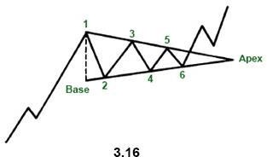
these features, symmetrical triangle is also called a coil. The essential requirements for the formation of this triangle pattern are 4 reversal points (points 1, 2, 3, 4). Thus, while drawing the converging trendlines, each line must be touched at least twice.
A symmetrical triangle is usually referred to as a period of consolidation before the price breaks out the trendlines. If the break is above the upper trendline this signals the beginning of an upward movement. On the other hand, a break below the lower trendline signals the beginning of a downward trend.
Ascending triangle: As we already
mentioned ascending triangle is a bullish pattern which indicates that the price of the security will go higher upon the completion.
The pattern is formed by two trendlines: a flat or a horizontal line and a rising lower line.
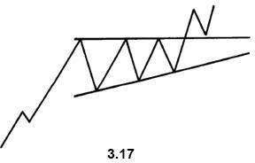
The price of the security moves between these two trendlines until it breaks out to the upside. The breaking of the upper line indicates the completion of the base and signals a bullish trend.
Though the ascending triangle usually appears in an uptrend and is considered a continuation pattern, sometimes it may appear in a downtrend. Therefore it is not unexpected to see an ascending pattern to develop at the end of a downtrend.
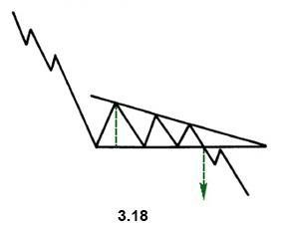
Descending Triangle: Descending triangle is a bearish pattern and is generally considered the opposite of the ascending pattern. It is formed by a
declining upper line and a flat bottom line. Here again, though it is a continuation pattern and is found in a downtrend, sometimes the descending triangle can be found in an uptrend. The downside signal is made when the price breaks out the lower trendline and shows the continuation of downside trend.

33

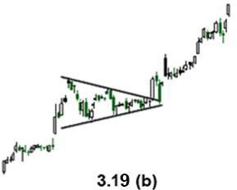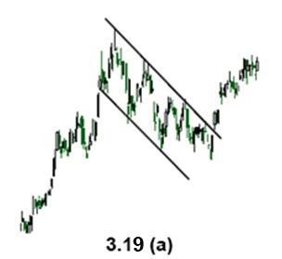Flags and Pennants: The formations of the flag and pennant patterns are quite common and since they are very similar in appearance they are treated together. They represent brief pauses in the dynamic market move.
What is required for flags and pennants to be formed is a sharp and straight line move followed by a brief pause in the trend.
The flag pattern looks like a rectangle which is formed by two parallel trendlines one of them acting as support and the other resistance (see figure 3.19a)
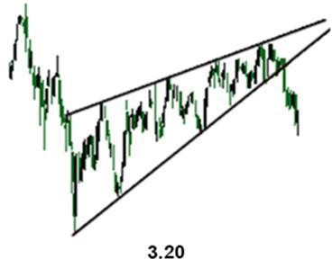
The pennant is constructed by two converging trendlines and looks like a small horizontal symmetrical triangle (see figure 3.19b). Both patterns are short term; in downtrend they tend to take less time to develop and may last maximum two weeks.
The Wedge: The wedge signals a reverse of the trend which is formed within the wedge. It is similar to a symmetrical triangle and consists of two trendlines (support and resistance). It is, however, a longer-term pattern and usually lasts till six months.
There are two types of wedges-falling and rising. A falling wedge slopes downward against the prevailing trend, while a rising wedge slants upward. In other words, a rising wedge is bearish, and a falling wedge is bullish.
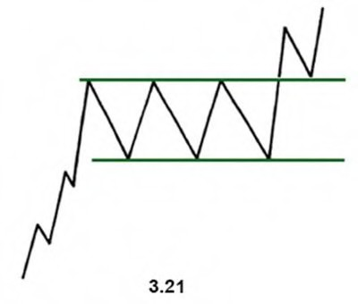
The Rectangle Pattern: The rectangle pattern represents a pause in the trend during which prices move sideways between two parallel lines. It is sometimes considered a consolidation zone or a congestion area.
By its forecasting value it is similar to the symmetrical triangle but with flat trendlines instead of converging trendlines.
There are two types of rectangle patterns- bullish and bearish. Bullish rectangle (see figure 3.21) is usually formed in an uptrend and signals trend’s upward direction. Bearish rectangle is formed in a downtrend and signals trend’s downward direction.

34

The Importance of Volume

Volume shows the number of stocks or contracts that trade over a particular time. Higher volume indicates higher degree of intensity or pressure. Being one of the most important factors in trade it is always analyzed and estimated by chartists. In order to determine the upward or downward movement of the volume, they look at the volume bars usually presented at the bottom of the chart. These bars show the quantity of stocks being traded within a certain period.
Volume plays a very important role in technical analysis since it is used to confirm trends and chart patterns. Any price movement is of more significance if accompanied by a relatively high volume than if accompanied by a weak volume. Thus, while considering a large price movement it is also important to examine the volume.

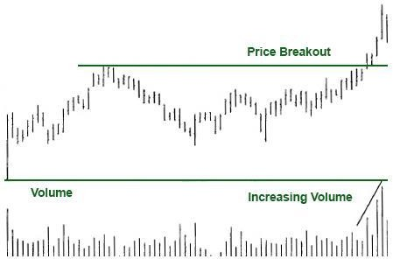

Figure 3.22

Volume and Trend
Volume should correspond to the trend. If the trend is upward and prices are moving up, volume should increase, and conversely, in a downtrend volume should decrease. By viewing the trend and volume together, technicians use two different tools to measure the pressure. If prices are trending higher, it becomes obvious that there is more buying than selling pressure. Technicians think that volume precedes price, which means that the loss of downside pressure in a downtrend or upside pressure in an uptrend show up in the volume figures before it is manifested in a reversal of the price trend. Volume is used by technicians to make an idea in the upcoming trend reversals. If the volume starts to decease during an uptrend, it signals that the upward trend is about to end.

35

Volume and Chart Patterns
Chart patterns, such as flags, triangles, head and shoulders, can be confirmed with volume. In most patterns there are some pivotal points essential for chartists to see what the chart is able to convey. If the volume lacks and does not confirm the pivotal moments on a chart, the importance of the signal formed by the pattern is weakened.

Conclusion
In this chapter we discussed the main types of charts-line, bar, candlestick, point and figure. As well as we covered the most commonly used reversal and continuation patterns which signal important trend reversals or trend continuation. There are other technical analysis tools which help to identify the trend. Let's look at this type of tools in our next chapter.

36

Chapter IV

Technical Indicators

What is a Technical Indicator?

Technical indicators are calculations which are based on the price and volume of a security.
They are used both to confirm the trend and the quality of chart patterns, and to help traders determine the buy and sell signals.
Indicators are used to identify trends, volatility, momentum and other aspects in a security to help in the trend’s technical analysis. They can be applied separately to form buy and sell signals, as well as can be used together, in conjunction with chart patterns and price movement.

Various Classifications of Technical Indicators

There are two leading groups of indicators: leading indicators and lagging indicators. Leading indicators precede price movement performing a predictive function. They are effective to be used during sideways trend or non-trending treading ranges. Lagging indicators, on the other hand, follow the price movement serving as a confirmation tool. These indicators are mainly used during trending periods (bullish or bearish).
By their form indicators either fall in a bounded range or not. Those indicators that are bound within a range are known as oscillators, which are also considered the most common type of indicators. Range here means the difference between high and low prices over a set time period. It shows the price volatility and price spread for a specific period.
Oscillators are used in non-trending markets where price fluctuates in a trading range creating a market situation where most trend –following tools don’t work effectively. They help traders profit from periodic sideways and trendless market. The oscillator becomes most useful when the price reaches near the upper or lower end of boundaries. The market is overbought when it is near the upper extreme, and oversold when it reaches the lower extreme.
Indicators can form buy and sell signals through crossovers and divergence. Crossovers are reflected when price moves through the moving average or when two different moving averages cross each other. Divergence happens when the price trend and the indicator trend move in opposite directions indicating that the direction of price trend is weakening.

  - Major Technical Indicators

There is a wide variety of technical indicators designed to signal certain actions in the market. However, not all of them are used widely by traders. The following indicators discussed below are of utmost importance for analysts and at least one of them is used by each trader.

37

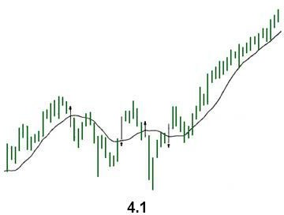
Moving Average: MA is one of the widely used of all technical indicators. As its name implies, it indicates the average price of a security over a defined time period. Its purpose is to signal that a new trend has begun, or the old trend has been reversed. It is used to track the trend, therefore it is a lagging indicator. Moving averages can be used to determine whether the security moves in a downtrend or in an uptrend based on the direction of the moving average. If a moving average is heading upward, the security is in an uptrend. If a moving average is moving downward, the security is in a downtrend (see figure 4.1 ).
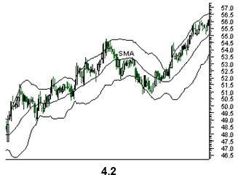
There are different types of moving averages that vary in the way they are calculated, but all they are interpreted in the same way. The three well known types of moving averages are: simple, linear and exponential.
Simple Moving Average (SMA): SMA takes the sum of all past closing prices over the specified time frame and divides the result by the number of prices in the calculation. One of the best ways to measure the strength of the long-term trend and make a forecasting that it will
reverse is to increase the number of time periods.

Linear Weighted Average: This indicator is less popular and is used to correct the weighting problem.
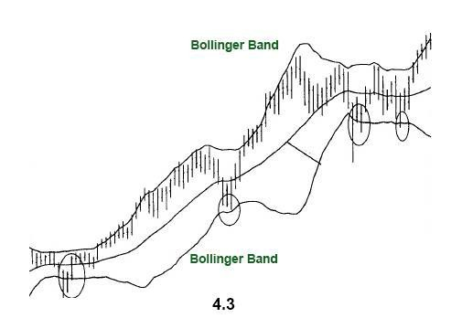
To calculate this, the sum of all the closing prices over a defined time period is multiplied by the position of the data point and then divided by the sum of the number of periods.
Exponential Moving Average (EMA): The most essential point to note in EMA is that it is more responsive to new information than the SMA. This responsiveness is one of the main reasons why this type of moving average is of choice among traders.

38

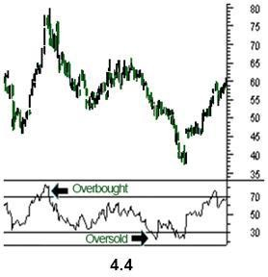
Bollinger Bands: This technique was developed by John Bollinger. The two trading bands are plotted around the moving average; the closer the prices to the lower band, the more oversold is the market, and the closer the price moves to the upper band, the more overbought is the market. When the market becomes more volatile, the bands move further away
from the moving average, becoming wider. During less volatile periods the bands move closer to the average becoming narrower. The narrowing of bands is often used by chartists as a signal that the volatility is going to increase.
Relative Strength Index (RSI): RSI is another well known indicator which was developed by J. Welles Wilder, Jr. It helps to signal the overbought and oversold conditions in a security. It is plotted in a range between 0 and 100.
A reading below 30 indicates that the security is oversold, and a reading above 70 suggests that the security is oversold. Because of the changes that take place in bull and bear markets, the 80 level is usually
considered overbought in bull markets, and the 20 level is referred to as an oversold level in bear markets.

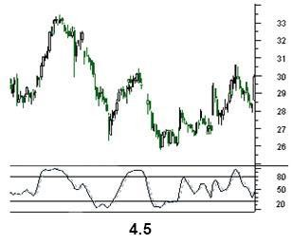
Stochastic Oscillator: The stochastic oscillator was popularized by George Lane. It is based on the main idea that as prices increase, closing prices should be near the highs of the price range, signaling upward momentum in the security. On the other hand, in downtrends, the closing prices tend to be near the lows of the price range, signaling downward momentum. The stochastic oscillator like the ADX is plotted within a range of 0 and 100 and signals oversold conditions below 20 and overbought conditions above 80 (see figure 4.5).
Two lines are used in Stochastic process- the %K line and the %D line. The former is more sensitive
and is the raw measure used to formulate the idea of momentum. The latter is considered a moving average of the %K. The %D is more important and provides the major signals. Though this indicator requires the past 14 trading periods in its calculation, it can be adjusted to meet the needs of the user.

Moving Average Convergence/Divergence (MACD): MACD was developed by Gerald Appel. This indicator consists of two exponential moving averages and helps to measure momentum in the security.
39

It shows the difference between two moving averages of closing prices and the centerline (the point at which two moving averages are equal).
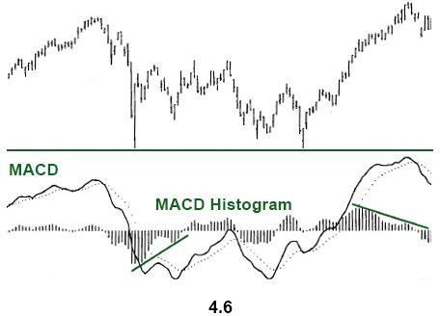
Aside from the MACD and the centerline, an exponential moving average of the MACD is plotted on the chart.
This indicator is used to measure the short –term momentum compared to longer term momentum:

MACD=short-term moving average – long- term moving average

If the MACD is positive, this means that the shorter term moving average is above the longer term moving average and an
upward movement is expected. Conversely, negative MACD signals that the shorter term moving average is below the longer-term moving average and suggests a downward momentum. A crossing in the moving averages takes place when the MACD line crosses over the centerline.
When the MACD line crosses above the signal line (dotted line) buy signal is generated. When the MACD crosses below the signal line a sell signal is generated (see figure 4.6).
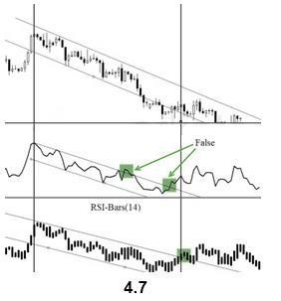
A very important aspect of the MACD indicator is the MACD histogram which is plotted on the centerline and is shown by vertical bars. It indicates the difference between two MACD lines. When the MACD lines are positive, the histogram is above the zero line. When the histogram is over the zero line, but starts to fall, the uptrend is weakening. When the histogram is below the zero line and starts to move upward, the downtrend is weakening.
RSI-Bars: RSI-Bars is an oscillator, developed by IFC Markets in 2014. It as the modification of Relative Strength Index (RSI). RSI-Bars characterizes a stability of a price momentum and allows a definition of a trend potential.
A distinctive feature of RSI-Bars is that this indicator takes into account the volatility of a considered instrument within the selected timeframe - values of RSI-Bars are defined taking into account the price values OPEN/HIGH/LOW/CLOSE (OHLC) and are displayed in the form of chart bars. This allows avoiding of false breakdowns of oscillator trend lines and that’s why traders may use methods of a chart analysis more efficiently in this case.
Technical indicators are primarily designed for analyzing short term market movements and, therefore, are most extensively used by active traders. For long-term traders most indicators are of little value; they can help to identify good entry and exit points for the security by analyzing the long-term trend.

40

Conclusion
Each point mentioned in this book forms a contributing part of technical analysis. Here is a brief
summary of what we’ve covered:

- Technical analysis is a method of analyzing the market action through past movements. It is based on three assumptions: the market discounts everything; price moves in trends and history tends to repeat itself.
- The difference between technical and fundamental analyses once more stresses the factors essential in technical trading and helps traders understand what type of analysts they are.
- Trend is one of the most important concepts in technical analysis. It is the direction that a security is headed and can be of three main types: uptrend, downtrend and sideways trend.
- A trendline adds a line to the chart showing the trend in the market.
- A channel line is the addition of two trendlines which act as support and resistance levels.
- Percentage retracements show how prices, before continuing in the original direction, retrace the previous trend by some percent.
- Price gaps represent such areas on a chart where no kind of trade has been executed.
- A chart is another important concept in technical trading. It is a graphical representation of price movements over a certain time frame.
- The time scale refers to the range of dates varying between seconds and decades. The price scale, which can either be arithmetic or logarithmic, shows security’s current price and compares it to the past data.
- There are four main charts used by traders: the line chart, the bar chart, the candlestick chart and the point and figure chart. Price patterns are certain formations that appear on charts creating a sign of future price movements.
- There are two types of chart patterns: reversal and continuation. Reversal chart patterns include the following patterns: head and shoulders, reverse head and shoulders, triple tops and bottoms, double tops and bottoms, saucer bottom, V-patterns. Continuation chart patterns are triangles (symmetrical, ascending and descending), flags and pennants, the wedge and the rectangle pattern.
- Volume shows the number of stocks or contracts that trade over a particular time. Higher volume indicates higher degree of intensity or pressure. It plays a very important role in technical analysis since it is used to confirm trends and chart patterns.
- Indicators are used to identify trends, volatility, momentum and other aspects in a security to
help in the trend’s technical analysis. There are two main types: leading and lagging.
Most widespread indicators are: a moving average, which shows the average price of a security over a defined time frame and can be of three types: simple, linear and exponential; RSI which helps to identify the overbought and oversold conditions in a security; Bollinger Bands which is also mainly used to signal the overbought and oversold conditions of market; Stochastic oscillator that compares the securities closing price to its price range over a specified time; MACD that measures the short-term momentum compared to longer-term momentum; RSI-Bars that characterizes a stability of a price momentum and allows a definition of a trend potential.
41

Bibliography

Technical Analysis of the Financial Market
By John Murphy

Technical Analysis of Stock Trends
By Robert D. Edwards and John Magee

The Art & Science of Technical Analysis: Market Structure, Price Action & Trading Strategies
By Adam Grimes

Technical Analysis Explained
By Martin J. Pring

How Charts Can Help You in the Stock Market
By William L. Jiler

Internet Sources
http://www.ifcmarkets.com/en/ntx-indicators/patterns http://www.ifcmarkets.com/en/ntx-indicators/technical-indicators

42

